YEAR 10 SCIENCE
DATA SHEET (EXAMINATION)

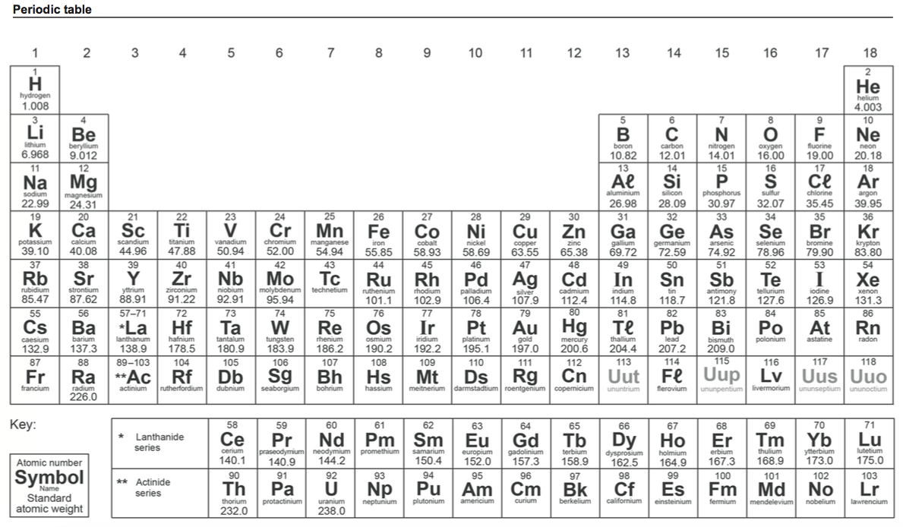

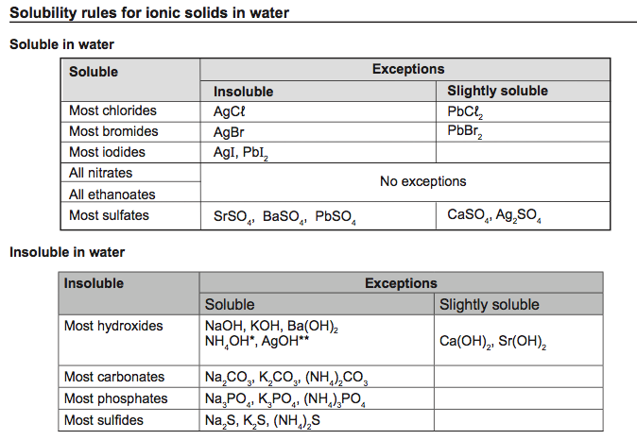

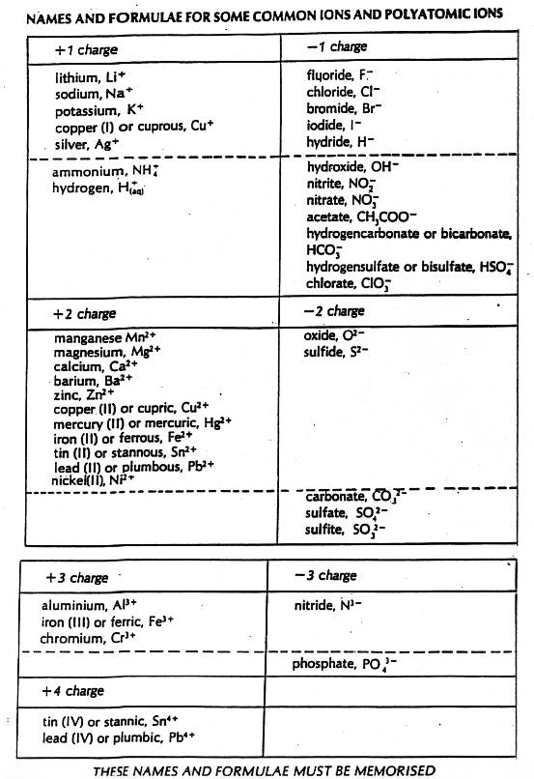

sp
d
t
Speed

v
s
t

Velocity

Acceleration

Equations of motion

m
p
v

Momentum p = mv

m
F
a
Force F = ma

Weight F_{w} = mg
m
F_{w}ww
g

Acceleration due to gravity g = 9.80 ms⁻²

Converting kmh⁻¹ to ms⁻¹ Divide the speed in kmh⁻¹ by 3.6 to get the speed in ms⁻¹.

